FER attempt #2:
In this attempt the idea for the model is to completely split the feature extraction and classification process in order for us to be able to use the best possible pre-trained model to undertake said process in this pipeline. After extensive research the best possible pre-trained models to use for each pipeline were found to be the RetinaFace model for the feature extraction part followed by an efficientNet model for the classification part.
The preprocessing pipeline is the same as the previous model
In this attempt I faced a problem where the training time was taking way too long, far longer than it should be and so I found the following issues that were contributing to this problem:
- The face detection function (RetinaFaceFERDataset) was running every time the function __getitem__ was called which was every epoch so the face detection on all images was done every epoch which was very wasteful. Therefor the next step si to make it so that the face detection is done only once and is done during preprocessing, not during training.
- Also during the training process, the function RetinaFaceFeatureDataset was running and extracting the features on the fly. This also adds a lot of overhead and should be implemented so that the feature extraction process runs during the preprocessing stage as opposed to during the training process
- There were also data pipeline issues in the code that should be fixed and of these problems are:
- Recreating datasets multiple times unnecessarily
- Stratified split was done twice with different datasets by mistake
- Transformations are being applied inefficiently
FER attempt #3 (train acc: 85.83%, val acc: 59.84%):
In this attempt we tried to implement the FER pipeline using a transfer learning approach with efficientNet for feature extraction and a simple Multi-layer perceptron (MLP) for classification.
We can break down the structure of the code into 4 main steps:
- Data Preprocessing: the function ‘Preprocess_and_save_faces’ is initiated and it’s job is to iterate through the train and test images and do the following:
- It reads the image, converts it to RGB and resizes it to a fixed size of 48x48 pixels
- The code is configured to skip face detection as the dataset we are using for now has the faces already cropped
- The processed images are then saved to a new directory ‘preprocessed_faces’ maintaining the original train/test split
- Feature extraction: it uses EfficientNet-B0, a CNN architecture that is pre-trained on the massive imageNet dataset, however the final layer of efficientNet is removed as it is a classification layer, which in turn turns it into a feature extractor. The mechanism is as follows:
- Applies a standard set of image transformations required by efficientNet (resizing to 224x224 and normalization)
- It then loads these images and passes them in to the efficientNet feature extractor in batches, and extracts a 1280-dimensional feature vector for each image
- All features and corresponding labels are collected and saved to a Pytorch file ‘extracted_features.pt’
- Classifier Model definition: a class FER_EfficientNetClassifier and the classifier is initiated, which is in its core a multi-layer perceptron and is built with 3 linear layers:
- Input layer: 1280 features 512 neurons
- Hidden layer: 512 neurons 256 neurons
- Output layer: 256 neurons 7 emotion classes
Batch normalization (BatchNorm1d) and dropout (Dropout(0.3)) are included after the first 2 layers to stabilize training and prevent overfitting
- Training and evaluation:
- First the training data is divided into a train(90%) and a validation set(10%). A stratified split is done to ensure that the class proportions stay the same
- The model is then set with hyperparameters: 50 epochs, Adam optimizer(0.001 lr), CrossEntropyLoss
In this attempt, slight modifications were done on the previous one in order to get a concrete result from the idea:
- Preprocessing pipeline changes: the face detection only happens once during the preprocessing part instead of the training part which will significantly cut training times and make the model more efficient.
- Feature extraction is only done once now during the preprocessing and the results are saved as a .pt file ready for it to be called upon and used during training
- BatchNorm layers were added as well to increase the stability of the training process
- Early stopping was implemented as well to combat any overfitting that may occur
- Parallel processing is also implemented (uses all CPU cores) which should speed the processing time significantly
- Instead of RetinaFace detector, we have decided to switch to OpenCV Haar Cascade as the retinaface was too slow and Haar Cascade is 100x faster with 95% accuracy of that of RetinaFace for FERs
Overall this attempts structure pipeline had turned out to be as follows:
Images -> retinaface -> cropped faces -> efficientNet features extracted efficientNet classifier classification
- A face extraction function (preprocess_and_save_faces) is initialized which does the following:
- Creates output directory, is implemented in such a way that running does not give an error even if that directory is already implemented
- Loads opencvs Haar Cascade model and does the face detection part using it
- A dataset class is initiated and what this class does is that it stores image paths and labels, loads each image using OpenCV, converts it to RGB (suitable format for retinaFace), then it runs the face extraction function, converts the resulting numpy array into a tensor and returns (face_tensor, label)

FER 4th attempt:
The pipeline for this attempt will be as follows :
Retinaface detects faces retinaface backbone detects the facial features from the image feature vector efficientnet classification

FER 5th attempt (at the 16th epoch, train acc:92.9%, val acc:67.76%):
To explain this attempt we will go through each section of the code and give an overview of it’s functionality first then we will deep dive and analyze these sections in depth:
- We will import the libraries to help us with building the structure of this model
- Data collection block (def gather_image_paths_and_labels(root_dir: str):
- What this block does: recursively scans dataset folders, detects emotion class from folder name
- What it returns: list of file paths, list of integer labels, sorted class names
- Pre-cached image dataset (class PreCachedImageDataset):
- What this class does is that it preloads all images into RAM once, then preprocesses them once (as in resizing them and making them into a tensor), which makes it so that only the training images need to get lightweight augmentations at runtime
- This is massively beneficial to the model because FERs tend to have small-resolution images in general which in turn makes the preprocessing overhead larger than the model cost. Caching massively speeds up training
- Augmentation block (def get_augmentation_transforms):
- This function applies some lightweight augmentations to the training dataset tensors, the augmentations are horizontal flips, normalization and random erasing
- Model builder block (def build_model):
- Loads pre-trained resnet18, along with its pre-trained weights, however in this model we will replace the classifier head belonging to the ResNet18 and putting in our own custom MLP (multi layer perceptron). The ResNet18 is particularly useful for this model as it transfers useful low-level features (edges, textures)
- The classification head was replaced by our own custom MLP which as the following structure:
Linear BatchNorm ReLU Dropout Linear BN ReLU Dropout Output
- This custom MLP has been initialized as the BatchNorm and Dropout in it stabilizes the training, prevents overfitting and encourages learning richer representations
- 1st training function (def train_one_epoch):
- This is the main training loop for one epoch
- The first key optimization here is that it initializes a non-blocking GPU transfer to the device which improves performance
- The second key optimization here is that it uses zero grad which gives a faster gradient reset
- This function then also does the accuracy and loss tracking for that epoch
- 2nd training function (def evaluate):
-sfdgfsgfsg
- 1st main training pipeline part (config and setup):
- This part first defines the paths for the data, the model type, the image sizes, gives values to the hyperparameters, initializes early stopping feature to stop training if results are stagnant, turns on caching
- In this part seeds are also set to ensure that the results that the model gives are reproduceable which is important for FER experiments
- 2nd main training pipeline part (loading the data):
- This part is responsible for collecting the data and then printing the statistics of this data to verify any class imbalances or other skewing in the data
- 3rd main training pipeline part (stratified train/val split):
- Takes a small part of the training data (15%) and uses it as validation for the model to see the results
- The stratified part of the split ensures that the class ratio is identical between train and validation, which is critical as some emotions (fear etc.) could be rare within the data
- 4th main training pipeline part (create dataset and loaders):
- Here we first initialize the PreChachedImageDataset, apply the augmentation transforms on the training dataset, then we form the train and validation data loaders
- We set the num_of_workers to 0 in the dataloaders to avoid pickle overhead as we are working with cached data (cached tensors cannot be pickled for multiprocessing)
- 5th main training pipeline part (build the model):
- In this part we give the command to build the model and move it to GPU
- This is helpful as we get to see the number of trainable parameters of the model as well which is helpful for debugging and verifying backbone freezing
- 6th main training pipeline part (loss and optimizer):
- The method we will use for calculating the loss for this model is going to be class-weighted loss
- We will use this method as the FER datasets are imbalanced and this loss compensates for unrepresented classes like fear etc.
- The optimizer we will use will be AdamW
- We will also integrate a scheduler (ReduceLROnPlateau) which will automatically reduce learning rate when val loss plateaus
- 7th main training pipeline part (the training loop):
- In this loop for each epoch the following will happen:
- The train_one_epoch fn will be called
- The evaluate fn will be called
- Metrics for that epoch will be logged
- The scheduler step is scheduled after that epoch is finished
- The best model is saved
- Early stopping is activated based on the metrics and the patience initialized
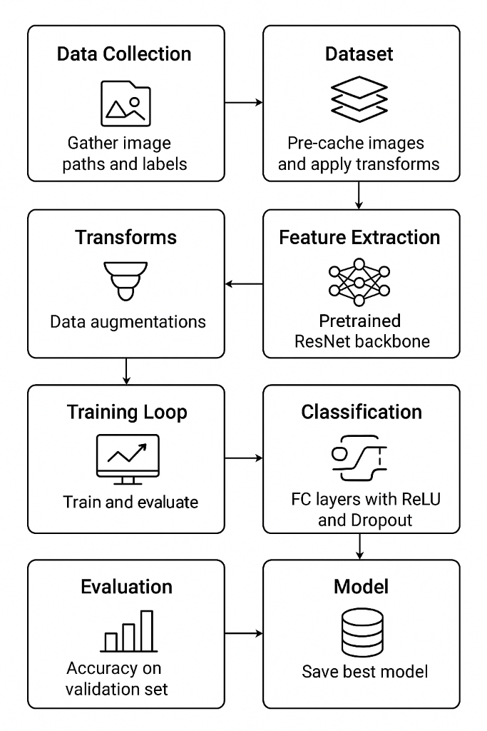

Possible Critical issues for this model:
- severe overfitting: 25% gap between train and validation accuracy is the main problem. So we need stronger regularization:
In build_model(), we could try a more aggressive dropout pattern by increasing the dropout percentage to 0.6 in both dropout layer
- insufficient data augmentation: we will add more augmentation transforms, in that case we can add rotation, color jitter, translation, and finally we will increase the probability of random erasing happening
- Learning rate issue: learning rate (0.001) could be decreased to 0.0003
- Class imbalance: since we have an imbalanced dataset (disgusted:547, happy: 8989) then we can maybe switch to a focal loss rather than the crossentropyloss as the focal loss would help in handling it by focusing on hard-to-classify examples
- Model architecture: the use of resnet34 instead of resnet18 could result in a better performance for the model
- Training strategy: to fix the overfitting problem we might try a different approach by using gradual unfreezing rather than training everything at once
FER Attempt #6 (at epoch 27/50 the train acc:59.18%, the val acc:63.87%):
In this attempt we are building and improving on the last previous model in order to mainly decrease the overfitting happening in the data and hopefully also increase the validation accuracy for the model overall.
In this attempt the major changes we have implemented are as follows:
- Loss function adjustment: we modified the loss function from crossentropyloss to focal loss as it handles class imbalance better and therefore could improve our overall accuracy for the model
- We have implemented mixup augmentations as well to the training dataset in order to improve model generalization and decrease the overfitting that was happening. Mixup creates new samples by performing a weighted average of two images and their labels. (we could also use Cutmix which is another data augmentation method that replaces a part of one image with a patch from another image and creates a new label based on the proportions of each image)
- We have also enhanced the data augmentations for the training dataset in general by adding the following:
- Random rotation of +/- 15 degrees
- Add a random color jitter to the image (brightness, contrast, saturation, hue)
- Add affine augmentations as well to preserve the parallel relationships to a certain extent
- Increase random erasing probability
- We will strengthen the regularization as well with the following:
- Increase the dropout rate in both dropout layers from 0.5 to 0.6
- Increased the weight decay from 0.0001 to 0.0005
- Decrease the initial learning rate from 0.001 to 0.0003
- Change the default model architecture from Resnet18 to a more modern version that is Resnet34, this will give us more capacity
- We will use a gradual unfreezing strategy during the training process:
- Phase 1: we will train only the classifier head for 5 epochs
- Phase 2: Unfreeze the last backbone layer for 10 epochs
- Phase 3: Fine-tune entire model for the remaining epochs (35 epochs)
- We will apply test-time augmentation TTA: this is a technique in machine learning that improves the prediction accuracy by averaging the predictions done by the model of the many augmented versions of the same image
- We will also add CosineAnnealingLR in the early phases of the training to improve the learning rate scheduling. CosineAnnealingLR is a learning rate scheduler used in machine learning during training that follows a cosine function, it helps the model converge effectively by balancing the different phase of the training
- We have also increased patience to 10 instead of 7
Results:
- The model was trained for 10 hours and had reached the 27th epoch before we had to stop the training as it was taking too long, the train accuracy had reached 59.18% while the validation accuracy reached 63.87%.
Critical issues:
- Loss values during the training was reaching 2000+ which is a huge value for loss as it was accumulating the raw loss values incorrectly. In the code particularly in the train_one_epoch function the metrics are updated correctly inside the else: block where the mixup is disabled for that patch. However the same metric update code is run again outside the if/else block, meaning it executes for every batch in the data loader, regardless of whether or not Mixup was used. This means that for the batches where mixup is skipped, the loss and accuracy metrics are added to the running total twice
- Automatically enable the GPU should we have it, and use FP16 to automatically speed up the calculation and reduce the memory usage by using less precision (16-bit floating point data format rather than 32-bit format)
- Removed the gradual unfreezing which caused the training to take exceedingly large times, now the model uses direct learning with better LR scheduling
- We also streamlined the augmentations, first by removing RandomAffine which was a slow transformation, we kept only the effective and fast augmentations. Then finally we reduced the mixup probability from 50% to 30%
- Optimized the configuration slightly firstly by going back to the ResNet18 model as it is faster than the ResNet34 model
FER attempt #7:
In this attempt we are looking to address the prior issues found in the previous model. Mainly the issues regarding the long training time, high loss values during the training and finally ensure that there is no overfitting happening whilst still maintaining a high validation accuracy.
The pipeline flow for this attempt is as follows:
- Core components:
  - LabelSmoothingCrossEntropy: this is a custom loss function that we have used as a regularization technique to prevent the model from being too overconfident, which is essential to improve the models generalization and overall accuracy. Inside this class there are the following fns:
- Initialization: in this we set the label smoothing factor to 0.1 which means that 10% of the true label’s probability mass is distributed to other classes
- Forward: in this function we compute the loss with smoothed values, the smoothed values here distribute a small probability to other classes, then assigns the remaining probability to the target class and calculates the final cross-entropy loss against the smoothed target distribution.
  - PreCachedImageDataset (dataset loader): in this class we tried to ensure that there would be no bottlenecks during the training process and so we pre-loaded all images as tensors into the memory during initialization. In this class we have the following functions:
- Initialization: in this part we iterate through all the image paths, load them as PIL and then convert them into tensors. We also applied normalization immediately to the validation dataset whilst we deferred the normalization for later for the train dataset
- Getitem: retrieves one sample from the dataset and applies the specified augmentations on-the-fly
- Advanced augmentations functions:
  - Mixup_data: linearly blends two random images and their labels together, in this function we draw the blending factor from the alpha mixup function
  - Cutmix_data: this function cuts a patch from one image and pastes it onto another, adjusting the labels by the pixel ratio. In this we calculate the proportionality value based on the exact area of the pasted patch, this value is used to weight the loss
- Utility and model functions:
  - Gather_image_paths_and_labels: reads and maps the raw file structure into a list of image paths and corresponding integer labels
  - Get_augmentation_transforms: in this function we define the transform pipeline for both the validation and train datasets. So for the train dataset we will apply: flips, rotation, color jitter, Affine, perspective, normalization and random erasing transformations. And for the validation dataset we will only apply normalization.
  - Build_model: in this function we have built the model architecture which we decided will be ResNet34 as a backbone to do the feature extraction and a custom classifier head that we will make to suit our application. The custom classifier is a sequential model with 3 batchnorm1D layers and has linearization and dropout. There is a final ReLU layer to do the classification
- Training and Evaluation functions:
  - Train_one_epoch: contains the core training logic, includes the forward and backward passes, and also integrates the augmentations. For the augmentations we alternate between the MixUp and CutMix on batches for better generalization. We also applied gradient clipping to prevent numerical instability, especially when using mixed precision (AMP) like we have
  - Evaluate: this is to evaluate the results of the predictions on the validation dataset, we implement TTA or test-time augmentation. This technique averages the predictions done on all the different augmentations relating to the same sample image. This leads to a small but significant accuracy boost in the model. We have also disabled the gradient calculations for memory efficiency and speed during inference
  - Train_advanced: this is the function that handles the main training orchestration and manages the epochs, learning rate and saving process. Uses the AdamW optimizer, this optimizer decouples weight decay form the gradient update, providing better regularization than the standard Adam. We also set the learning rate scheduler to OneCycleLR which is a highly effective for fast training and high accuracy.
  - Save-checkpoint: saves a dictionary containing the model’s state, optimizer state, epoch number and accuracy metrics allowing training to be resumed or the model to be deployed

